**Step 1: Go to**[https://colab.research.google.com](https://colab.research.google.com/)**in Browser and Click on New Notebook.**

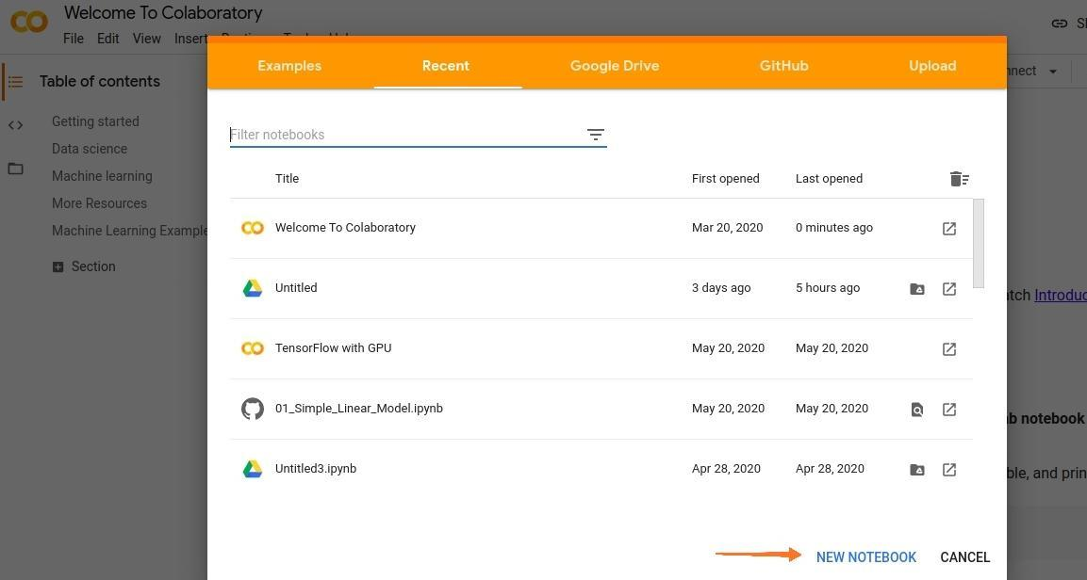

**Step 2: We need to switch our runtime from CPU to GPU. Click on Runtime > Change runtime type > Hardware Accelerator > GPU > Save.**

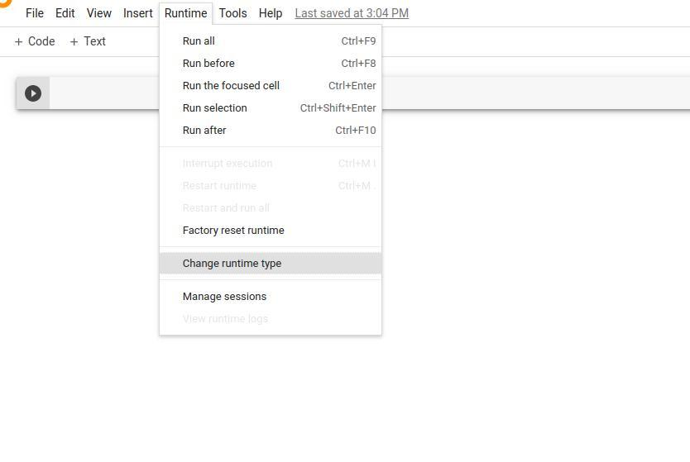

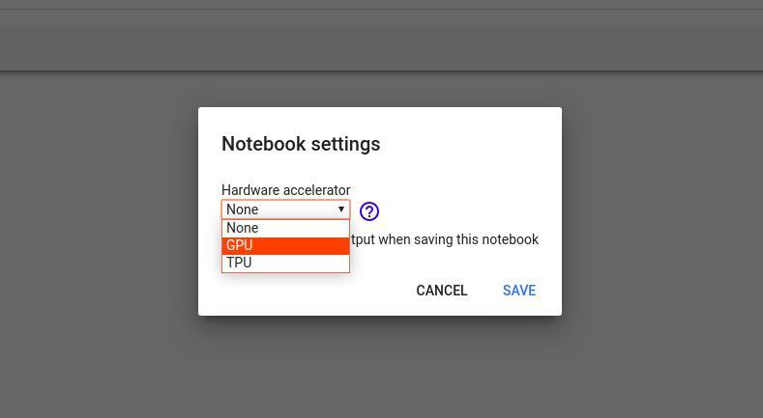

**Step 3 (no longer required): Completely uninstall any previous CUDA versions.We need to refresh the Cloud Instance of CUDA.**

**!apt-get --purge remove cuda nvidia* libnvidia-\***

**!dpkg -l | grep cuda- | awk '{print $2}' | xargs -n1 dpkg --purge**

**!apt-get remove cuda-\***

**!apt autoremove**

**!apt-get update**

Write code in a separate code Block and Run that code.Every line that starts with ‘!’, it will be executed as a command line command. 

**Step 4 (no longer required): Install CUDA Version 9 (You can just copy it in separate code block).**

**!wget https://developer.nvidia.com/compute/cuda/9.2/Prod/local_installers/cuda-repo-ubuntu1604-9-2-local_9.2.88-1_amd64 -O cuda-repo-ubuntu1604-9-2-local_9.2.88-1_amd64.deb**

**!dpkg -i cuda-repo-ubuntu1604-9-2-local_9.2.88-1_amd64.deb**

**!apt-key add /var/cuda-repo-9-2-local/7fa2af80.pub**

**!apt-get update**

**!apt-get install cuda-9.2**

**Step 5: Now you can check your CUDA installation by running the command given below :**

!nvcc --version

Output will be something like this: 

vcc: NVIDIA (R) Cuda compiler driver

Copyright (c) 2005-2018 NVIDIA Corporation

Built on Wed_Apr_11_23:16:29_CDT_2018

Cuda compilation tools, release 9.2, V9.2.88

**Step 6: Run the given command to install a small extension to run nvcc from the Notebook cells.**

!pip install git+https://github.com/andreinechaev/nvcc4jupyter.git

**Step 7: Load the extension using the code given below:**

%load_ext nvcc_plugin

**Step 8: Execute the code given below to check if CUDA is working or not.**

To run the code in your notebook, add the %%cu extension at the beginning of your code. 

* CPP

|  |
| --- |
| %%cu  #include <iostream>  **int**      main()  {      std::cout << "Welcome To GeeksforGeeks\n";  **return** 0;  } |

Output: 

Welcome To GeeksforGeeks